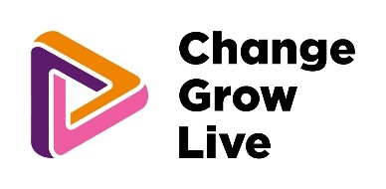

Step one: Are you ready for detoxification?

We recognise that the time before detoxification can be difficult. We want you to be prepared for your next step. This form will help you to check that you are ready and supported for your detox. Please complete it with your local provider before you submit your choices on the Pan London Framework Page. This form should be completed when you make your initial plans and choices for your detox and revisited face to face with your local provider key worker 7-10 days prior to your admission date and emailed to your chosen provider via PanLondonDetoxReady@cgl.org.uk

Before you complete your online choices form your service needs to: | Tick and date when you are ready
Provide a named worker contact for each person referred – this will support smooth and safe transition into detox, and transition from detox at the end of the placement,
Have the information to complete the online referral forms, including:
- your health
- living situation
- GP contact
- your physical and mental wellbeing
- contact information
- loved ones and dependents
- emergency contacts
- your drug and/or alcohol related needs.

- Have asked you to attend your local service or GP for blood tests related to your stay – these may include Liver Function Tests for alcohol related admissions and full blood count for Opiate related admissions.
We may ask for additional blood tests once we have received your referral.
Have spoken to you and clearly established that this is what you want to do.

Have taken your request for a detoxification to your local providers Multi-Disciplinary Team (MDT) meeting to ensure that local clinicians are supportive and engaged in your treatment and support.

Have spoken to you about harm reduction as your detox admission date is approached.

Ensure there are plans in place for anyone you care for, children or dependents, and pets, whilst you focus on your own needs and your detox.

Have talked to you about:
- your expectations
- what to bring with you
- what to expect in terms of medicines and possible withdrawal symptoms during your detox
- boundaries and relationships within the detox.

Have talked about visiting the detox and whether this is something you want to do.

Shared the welcome pack and house rules for the detox with you.

Completed the ‘Referring Community Provider – Clinically Authorised sign off’ form and sent this to PanLondonDetoxReady@cgl.org.uk
Date of completion:

