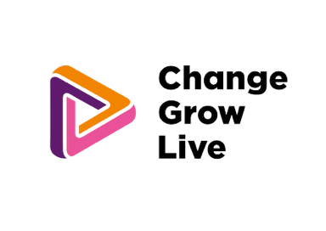

**Step one: Are you ready for detox?_**

We know this is likely to be a difficult time for you and we want you to be prepared for your next step.   
This will help you to check that you are ready and supported for your detox.

You should complete this form when you make your initial plans and choices for your detox, and revisit it   
face-to-face with your local provider key worker 7-10 days before your admission date. It can then be emailed   
to your chosen provider.

|  |  |
| --- | --- |
| **Before you complete your online choices form, use this table to check you have everything you need. Your service needs to:** | **Tick and date when you are ready** |
| Provide a named worker contact for you, to support smooth transition into detox and smooth and safe transition from detox at the end of the placement. |  |
| Have the information to complete the online referral forms, including:  - your health  - living situation  - GP contact  - your physical and mental wellbeing  - contact information  - loved ones and dependents  - emergency contacts  - your drug and/or alcohol related needs.  - info about any other prescribed medication other than what you get from your GP |  |
| Have asked you to attend your local service or GP for blood tests related to your stay. These may include liver function tests for alcohol-related admissions and full blood count for opiate-related admissions. |  |
| Have spoken to you and clearly established that this is what you want to do. |  |
| Have taken your request for a detoxification to your local provider’s multi-disciplinary team meeting to ensure that local clinicians are supportive and engaged in your treatment and support. |  |
| Decide whether a safe and planned reduction in your drinking will be helpful for you in the lead up to your detox. |  |
| Speak to you about harm reduction as your detox admission date is approached. |  |
| Ensure there are plans in place for anyone you care for, children, dependents and pets, while you focus on your own needs and your detox. |  |
| Have talked to you about:   * your expectations * what to bring with you * what to expect in terms of medicines and possible withdrawal symptoms during your detox * boundaries and relationships within the detox. |  |
| Talk about visiting the detox and whether this is something you want to do. |  |
| Share the welcome pack and house rules for the detox with you. |  |
| Date of completion: |  |