## Summary

Naloxone supply has been an important part of our harm minimisation approach in reducing drug related deaths for the last six years. The aim of this strategy is to increase distribution and impact of naloxone supply through services and partner organisations so that it may help those within structured and non-structured treatment. An important part of this strategy is increasing distribution to family, friends and anyone who comes into contact with individuals who are taking opioids.

## Background

Naloxone is a drug which temporarily reverses the effects of opioids such as heroin, methadone, and morphine. UK Guidelines on Clinical Management of Drug Misuse fully endorses the use of naloxone in overdose management and prevention.

On the 1st of October 2015 the Human Medicines (Amendment) (No. 3) Regulations 2015 (2015/1503) came into force. This allowed injectable naloxone to be supplied by:

‘*Persons employed or engaged in the provision of drug treatment services provided by, on behalf of or under arrangements made by one of the following bodies: a) an NHS body; (b) a local authority; (c) Public Health England; or (d) Public Health Agency.’*

Amendments in February 2019 to the Human Medicines Regulations 2015 enabled supply of nasal naloxone to individuals without the need for a prescription, patient group direction or patient specific direction.

## Where are we now?

From 2015 to date our strategy has focused primarily on distribution to those within structured treatment. In the last 12 months, Change Grow Live has had 107,567 people in structured treatment and 49,592 of those individuals were taking opioids.

By the 19th of March 2020, **16,043** people on our current opioid caseload had been issued with naloxone **(52%).** During the Covid19 lockdown period we achieved our greatest distribution of naloxone into the community to date. By the 21st of July 2020 distribution of naloxone, mainly via outreach, had risen to **70%** of our opioid caseload. This represented an additional **7,418** people using our service who had been issued kits. We achieved this by taking naloxone to the person rather than relying on the person coming to us. We want to capture this learning and use it to inform how we build naloxone into future service delivery.

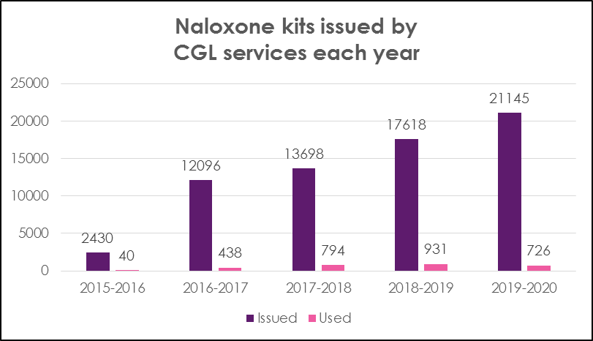

As an organisation we have increased the supply of naloxone kits year on year through integration across all aspects of the organisation, focusing on:

* Naloxone champions in every service.
* Embedding naloxone strategy into our organisational strategy.
* Making our naloxone strategy a priority throughout the organisation up to board level.
* Recognising our naloxone strategy as fundamental in our harm reduction approach.
* Embracing innovations that can increase the distribution of naloxone into every community.

Nevertheless, our data shows that a significant percentage of individuals who are within structured treatment on the opioid caseload are still without naloxone. The use of Tableau provides an opportunity for intelligent targeting and concentrating distribution in a tiered approach to those at greatest risk of overdose.

## What steps do we need to take to meet the aims of this strategy?

* Raise naloxone’s profile across the public and professionals. This will help to remove stigma. Take every opportunity to educate people about naloxone and the misconceptions around its use to encourage people to accept training and a kit.
* Take time to listen to people’s understanding and beliefs and provide appropriate information about naloxone.
* Provide positive reinforcement such as stories about how individuals have used naloxone to save the lives of others, or how naloxone has been used to save their own life. Personal stories can be powerful in highlighting the positive impact of naloxone.
* Offer nasal naloxone to those who do not want a product with needles.
* Revisit the naloxone conversation. Even when people have already accepted a kit and have been trained, kits do expire. It isn’t enough to issue a kit with training and expect a person to remember this years later. There is also a chance that kits get used or lost, or the needles may have been used rendering the preparation useless. It is important we think of the supply of naloxone as an ongoing conversation.

## Reaching those not in structured treatment

## Pharmacies

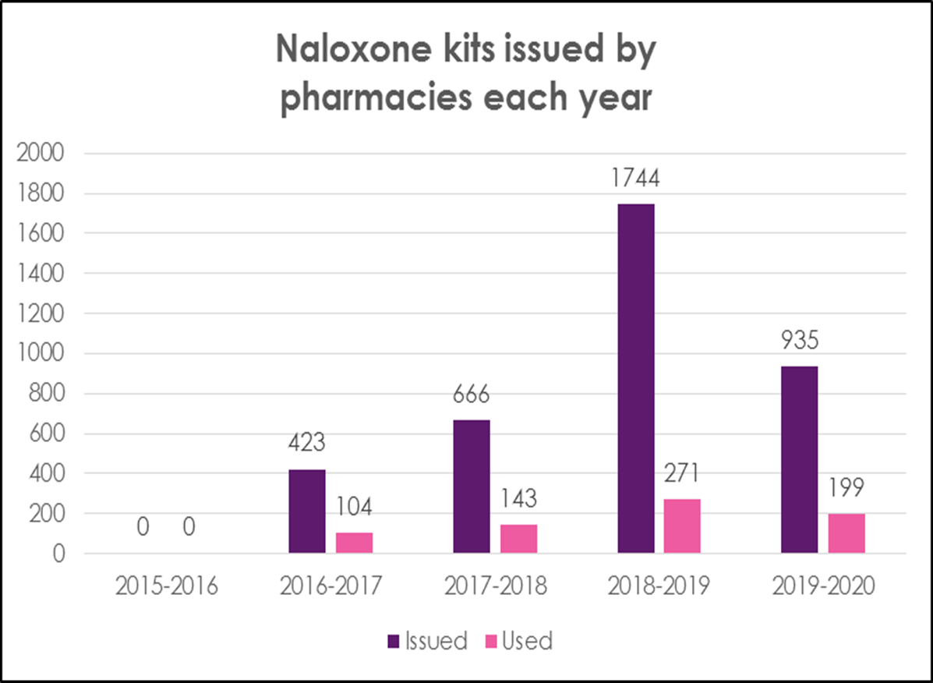

Pharmacies are a key ally with 3,768 kits given out since 2015. 60% of these are from our joint work in Birmingham. A key piece of data which characterises the variation in impact across locations is the percentage of kits that have been used in overdose situations. 717 pharmacy supplied kits have been used in overdose situations. This represents **19%** of kits issued by pharmacies as opposed to **4%** of those supplied directly by our services. There is no conclusive evidence for why this may be, although it is likely that overdose situations are more common among those in non-structured treatment. As we improve our approach in supplying kits and focus on impact rather than simply numbers given out, pharmacy commissioned naloxone supply will be a core offer.

**Naloxone Peer Educators (NPE)/ Peer to Peer (P2P)**

In 2012, the Scottish Drugs Forum (SDF) launched a naloxone peer education initiative. This quickly showed that peer educators were able to engage hard to reach groups. In fact, Scotland saw a significant increase in training and supply to those at risk of opioid overdose within the first year. Inspired by this, Change Grow Live have invested in peer-to-peer programs whereby Naloxone Peer Educators who are actively using our service engage with their peers to distribute naloxone. Reflecting the SDF findings, Naloxone Peer Educators’ approach and credibility allows them to connect with current service users who have previously refused training and naloxone kits.

Our initial pilot of this programme in the Northwest resulted in 265 kits being given out in the period 4th of November 2019 to 4th of January 2020. Of these:

* 70% (185) of people were issued with their first kit
* 58% (154) of people were issued to people in service
* 42% of people issued a kit were not in structured treatment
* 20% (30) of people issued a kit in structured treatment had previously refused a kit

The success of this programme has demonstrated the need to roll this out across all Change Grow Live clinical services. We can utilise peer lived experience and ability to engage hard to reach individuals and cohorts.

## Hospitals

Making naloxone available in A&E and at discharge from wards would enable us to directly supply individuals at high risk of repeat overdose. This would be in addition to developing the remit of our hospital liaison nurses so they can educate staff, patients, and families around naloxone.

## Ambulance services

Naloxone kits being supplied at the scene of an overdose to the person (and/or the person with them) who has overdosed is vital, especially if they refuse to be transferred to hospital. This may be the only contact with a healthcare professional they have. We are currently in conversation with West Midlands ambulance service to pilot this.

## Police

Having completed an initial pilot with West Midlands police to carry nasal naloxone, we have created a series of resources for officers. These include a training template, wallet sized advice cards with Change Grow Live contact details for police to distribute, and a process for supplying kits to individual officers. We are keen to support and facilitate replication of this model across the UK. Discussions with several other police forces are underway with the aim of having Nyxoid kits with all forces by end of 2021.

**Approved Premises (APs)**

Approved Premises had noticed a spike in drug-related deaths over the last couple of years. Following initial discussions with Public Health England we have begun a pilot for them to act as an engaged partner of drug and alcohol services to supply naloxone to residents following appropriate training. The rollout across 40 Approved Premises has taken place and has set the example for others in the sector to replicate.

## Hostels and Homeless Shelters

We plan to work with hostels and homeless shelters in a similar manner to Approved Premises for them to provide naloxone kits to residents as one of our engaged partners. If we can expand this offer to organisations like the Salvation Army the penetration of naloxone will be far beyond geographical/commissioned boundaries and reach people that we may never otherwise have had contact with.

## Prisons

We want to work with prison healthcare providers to provide kits and training to people being released. This is both where we provide services in prison, and also in areas where the provider is different. The Through the Gate programme and the success of the Nyxoid pilot provide opportunities to build upon for all our services. Prison liaison roles similar to hospital liaison would hugely impact the success of this delivery model.

## How will we support supply through external organisations?

We will provide an e-learning module that is accessible to all online, supplemented by face to face or virtual training/support. Crucially, this training will cover both Prenoxad and Nyxoid.

**Addressing barriers**

Working with both internal and external stakeholders we will focus on:

1. **Funding**- There is no national take-home naloxone program in England, instead it is dependent upon the individual commissioned service. Continued funding commitment to this expanded strategy by Change Grow Live’s commitment to continued funding of this expanded strategy will ensure it remains at the forefront of our ambition to reduce drug related deaths.

2. **Education**- Stigma around people who use drugs remains an issue. To address this, we need to work with stakeholders to promote naloxone as a lifesaving intervention in line with other mainstream public health promotion campaigns.

3. **ACMD** – Direct engagement with the advisory council to share data, best practice and innovative practice will hopefully help shape national strategies.

4. **Product availability**- Currently Nyxoid (naloxone nasal spray) is not manufactured in the UK. Lobbying for production within the UK will remove concerns around supply and reduce costs associated with importation.

## Conclusion

We have demonstrated we can deliver an efficient and successful take-home naloxone service. Our efforts in increasing distribution and impact of naloxone supply have potentially saved many lives. We also acknowledge, however, that there is a long way to go. We hope to share and apply what we have learned both within our services and with other organisations.