KS3 – Year 9 Lesson plan for session 3
Positive Choices Coventry

Lesson number: 3

Links to PSHE Association Programme of study  See:  http://www.pshe-association.org.uk/resources  Links to FRANK drug information https://www.talktofrank.com/  Positive Choices 02476 553130 | KS3 Alcohol and Personal Safety  Learning outcomes;  - Understanding the stages of intoxication  - Knowledge of the risks associated with alcohol use
Time required | 30 minutes (depending upon pupil’s needs and teacher choices).
Required resources and  Handout 2a-risks associated with underage drinking  Handout-9b how many units  Handout-9c effects on the body  PSHE and Citizenship GCSE. This series is relevant for teaching teenagers about personal welfare and the effects of drink and drugs.  https://www.bbc.co.uk/teach/class-clips-video/pshe-gcse-ks4-drink-and-drugs-my-story/z69cvk7  YouTube video-Part 4: What do we feel at different stages of intoxication? | Basic knowledge and understanding of drugs (teacher). Positive Choices can provide basic drug awareness training to all PSHE teachers.  Pens/pencils  Flip chart paper and pens  Note pads  Handouts  YouTube video showing the different stages of intoxication-please note that this is an Australian video so the law will be different (legal drinking level) but the process and stages are standard and gives the viewer a good insight into the stages that a drinker will go through during their drinking episode. Please view to ensure it is suitable.
Background | Young people may become tempted or encouraged by others to try alcohol. Understanding the effects of alcohol on the body and identifying risks of drinking alcohol will enable young people to make an informed choice.  The teacher delivering this session will need a basic level of drug awareness to manage any questions asked and provide factual information about the topic.  Be mindful that young people may know someone or are exposed to substance use within the family home, someone with lots of knowledge around substances may need meeting with after to ascertain level of risk or need for additional support
Group agreement | Points to include in group agreement are:  - Listen to each other in turn  - Knowledge and experience come in different level-all questions are valid ones  - No personal questions aimed at teacher or students  - Be respectful
Activity | Introduction:  Today’s session is to look at the risks associated with alcohol.  In the last session we started to look at the effects alcohol has on the person. This session we will continue to look at the effects on the person and the risks that are associated with alcohol use.  Alcohol  There are different stages of intoxication that people go through when drinking alcohol.  Teacher-If you have access to YouTube you can show the short video to show the stages of intoxication or discuss the image below.  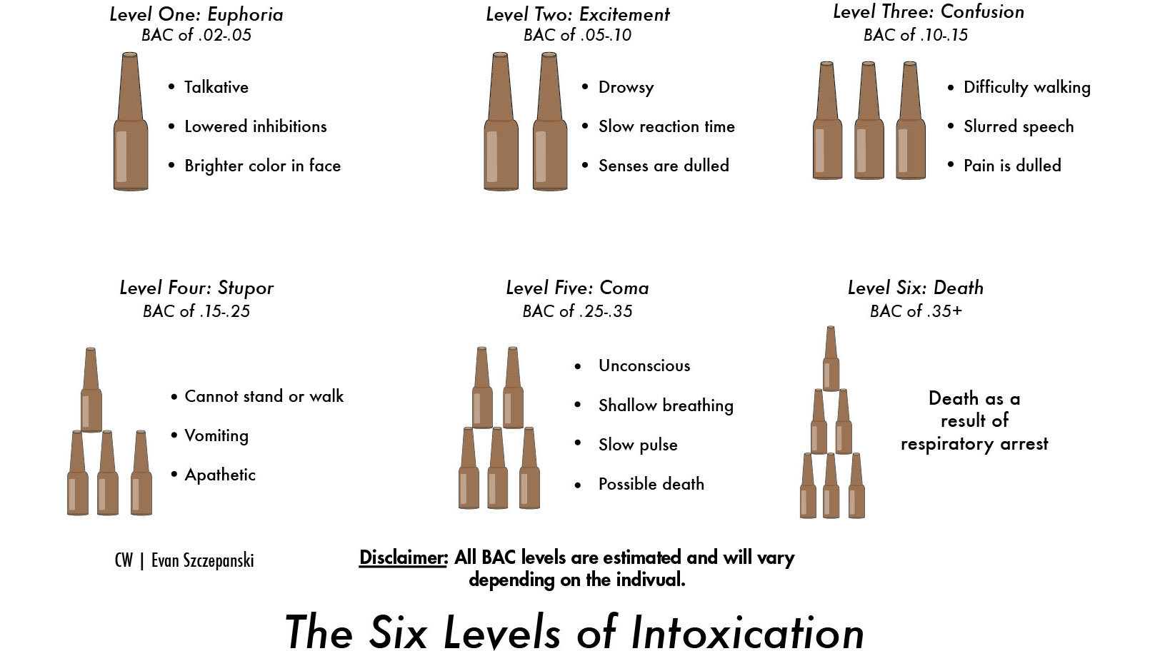  The above image shows the different stages of intoxication-BAC refers to blood alcohol concentration, which is the alcohol levels within the blood.  Ask the group if they know what the different levels of intoxication are?  Split the group into 6 groups and give each group a stage of intoxication. Ask the groups to discuss the effects each stage has on the person (physical and emotional) and what the associated risks are with their stage.  Examples:  Stage 1  Talk more, overconfident, lose attention span, more daring, lack of will power and lack of judgement  Risk:  Lose inhibitions-unwanted sexual attention or behaviour, unprotected sex, make decisions that you would not make sober and will likely to regret.  Drink more than intended-start drinking shots for example  Forget address when in taxi, lose possessions  Stage 2  Slower response time, starting to feel unbalanced, struggle to focus and remember, feel sleepy/drowsy  Risk:  Injury-step out in front of a car, fall down stairs, fall over  Unable to remember personal information  Fall asleep leaving your self exposed to assaults, robbery  Stage 3  Staggering, confused, become emotional, speech slurring, over affectionate, aggressive or violent, will not feel pain  Risk:  Lose friends that you came with  Not able to communicate to people  Become aggressive and fight others or emotional and extremely vulnerable  Fall and seriously injure yourself but will not be able to recognise the severity until following day  End up in hospital  Stage 4  Unable to walk, slumped in doorways, not able to communicate, in and out of consciousness, unresponsive.  Risk:  Vulnerable to being sexually or physically assaulted  Possessions removed (robbed)  Fall asleep or become unconscious-hyperthermia-death  Sick whilst asleep-risk of overdose (choking)  Stage 5  Breathing becomes slow and shallow, heart rate slow, unconscious, coma  Risk:  Overdose/alcohol poisoning  Hospital  Hyperthermia if left outside  Stage 6  Stop breathing  Risk: death  Spend time discussing the risks of drinking alcohol and what risks are prevalent to each stage.  When discussing the risks encourage the group to consider; how they would get home, identify licenced taxi’s, what they would do if separated from friends, unprotected sex or regret any sexual activity whilst intoxicated, vulnerabrisk of sexual assault and exploitation, getting into altercations, hyperthermia, alcohol poisoning, hyperthermia,
Assessment | Check in with the group to ensure that they are ok and if anyone wants to talk have time available for them.
Plenary | Depending on the professional judgement of the teacher and pedagogy choices they have made, a consensus should be reached on each of the questions above.  Some teachers may wish to write and record this thinking, as a set of ‘class notes’, others may feel it sufficient to hold the discussion without any ‘formal’ record.

