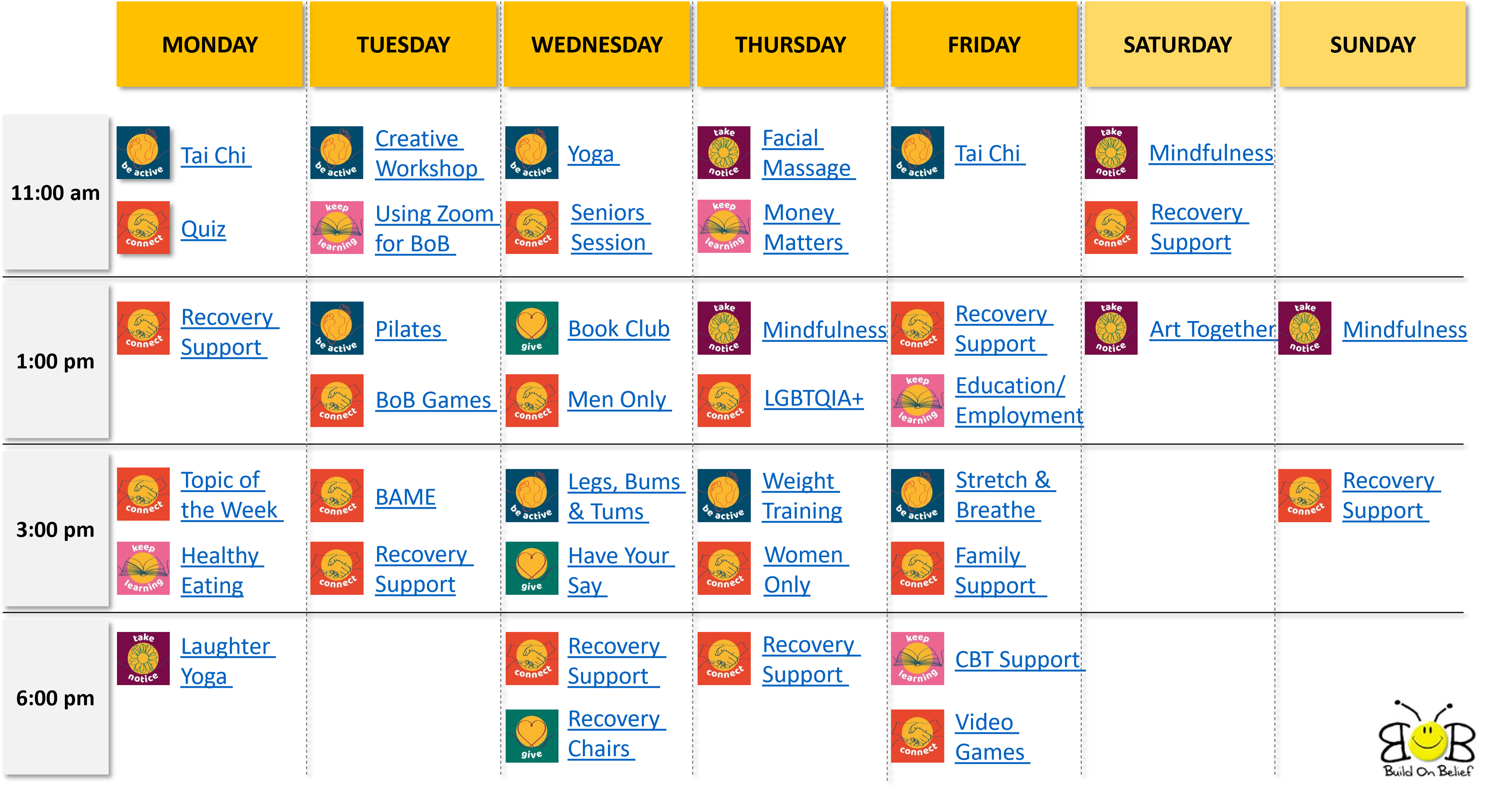

To Join one of the meetings see the log in details on page 2 below. Either CLICK on the link, go to Zoom on the internet https://zoom.us/ and enter the meeting ID and Passcode or use the instructions to dial in on the phone

Online Support 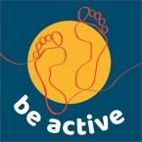
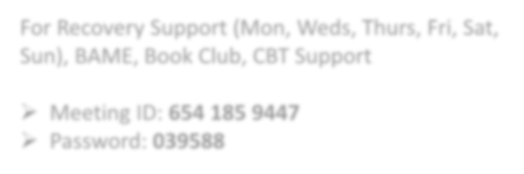
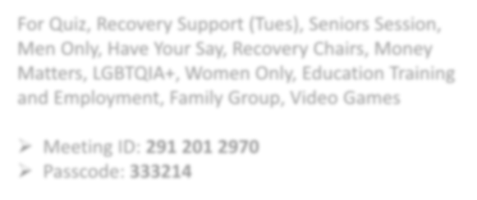
Want to access by telephone?
Enter the details on ZOOM that are related to your group:
For Recovery Support (Mon, Weds, Thurs, Fri, Sat,
Sun), BAME, Book Club, CBT Support CLICK HERE

Meeting ID:
654 185 9447

Password:
039588

For Quiz, Recovery Support (Tues), Seniors Session,
Men Only, Have Your Say, Recovery Chairs, Money
Matters,
LGBTQIA+,
Women Only, Education Training
and Employment, Family Group, Video Games CLICK HERE

Meeting ID:
291 201 2970

Passcode:
333214

- Call one of the 4 numbers:
+44 203 051 2874 UK
+44 203 481 5237 UK
+44 203 481 5240 UK +44 131 460 1196 UK
- You’ll be asked to enter the Meeting ID and to press #
- You’ll be asked to enter a participant ID or press # to continue. Just press # or wait 3 seconds and you’ll be asked for the meeting password
- You’ll be asked to enter the meeting password and to press #
To be added or removed from the mailing list please email bob@buildonbelief.org.uk

