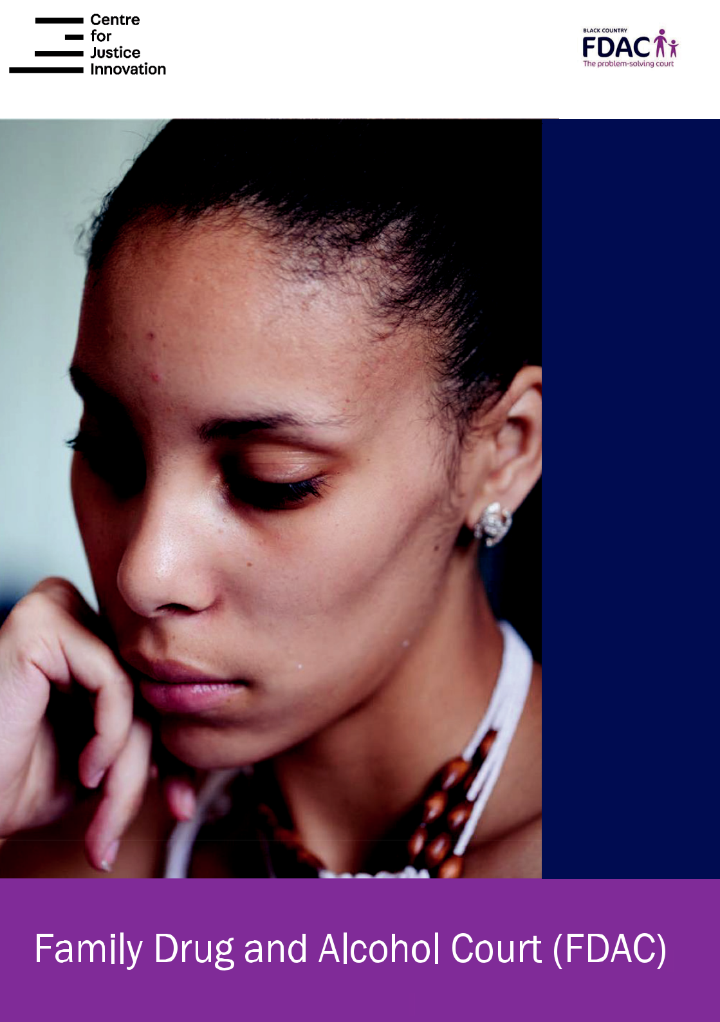

The Trial for

Change –

FDAC’s

parenting

assessment

model


Introduction to FDAC

FDAC is an evidence-based intervention programme offered to families entering care proceedings where their substance misuse and/or other problems, such as domestic abuse or mental health, are significant factors. FDAC is a different kind of court from ordinary care proceedings. Based on the principles of therapeutic jurisprudence, it is a problem -solving court that not only adjudicates but also aims to help parents solve their own problems.

FDAC believes that helping families to overcome their problems and raise healthy, well-adjusted children is the best possible outcome for children. Where that is not possible, FDAC helps to ensure that children are found alternative long-term placements without undue delay whilst continuing to encourage parents to keep trying to overcome their problems.

The Trial for Change parenting assessment model

The FDAC parenting assessment model is based on parents being offered a time-limited ‘trial for change’ within care proceedings. The ‘trial for change’ is best described as “intensive assessment and support to parents, monitored closely by the court”.

Problem solving is at the heart of the assessment model. The aim is to help tackle the problems that prevent parents from succeeding, especially drug and alcohol misuse, domestic abuse, mental health problems and severe poverty. It also aims to strengthen parent-child relationships and other relationships and to help families build a lifestyle that is safe and child centred.

A ‘trial for change’ is an individualised programme of assessment, treatment and support:

- giving parents the best possible chance to solve their problems, while

- testing whether they can do that in a timescale compatible with their children’s needs, and

- using resources that FDAC can be sure of accessing quickly from its network of partner agencies or its own service.

Every family in FDAC is offered a ‘trial for change’, even if the prognosis for change seems poor. The ‘trial for change’ allows us to identify, without undue delay, those children who need an alternative long-term placement, and to do so in a way that feels fair and supportive to parents.
How does the model work in practice?

The FDAC assessment of a parent’s capacity to meet their children’s needs starts on the first day of their contact with FDAC, and is an assessment over time. It enables parents to engage with the FDAC specialist team in a meaningful way and to show the court the changes they are making. problems and the impact these have had on their parenting.

1. Identifying what needs to change – The Initial Parenting Assessment

The Initial Parenting Assessment is completed within two weeks of the first hearing in the FDAC court. The assessment asks parents what problems they want to solve, and explores with them the history of their substance misuse, domestic abuse, mental health and other

- Devising the ‘trial for change’

Once all the above information has been collected and analysed (and still within the initial two-week period) the specialist team holds a Formulation Meeting to agree their proposals for the ‘trial for change’ and develop the parent’s Intervention Plan. The Formulation Meeting considers the psychosocial mechanisms by which the children have been exposed to risk and draws on the latest available evidence in order to arrive at an understanding of the family’s needs that is multi-disciplinary and holistic.

This is followed immediately by the Intervention Planning Meeting, chaired by the team’s clinical lead or service manager. The assessment is explained and the Intervention Plan (the ‘trial for change’) discussed and agreed with the local authority, adult treatment workers and other relevant professionals, parents, and the children’s guardian.

The Initial Parenting Assessment is sent to all parties and presented to the court at the second hearing (usually Week 3 of the proceedings). The report sets out the information gathered and the team’s analysis, and it explains the team’s understanding of the problems that the ‘trial for change’ will need to solve and the timescale for doing that.

- Getting the ‘trial for change’ started – The Intervention Plan

At this second hearing the court also receives the Intervention Plan, the first stage of the ‘trial for change’. The court gives its authority to the timescales and objectives of the ‘trial for change’ when, during this court hearing, it ratifies the Intervention Plan and invites parents to sign up to joining FDAC.
- Updating and developing the ‘trial for change’ – Subsequent IPM Minutes

Subsequent Intervention Planning Meetings are held every 4 to 6 weeks, to review, update and develop the ‘trial for change’. Before each meeting the FDAC team reformulates the Intervention Plan on the basis of the progress made by parents and any new information or developments. This iterative process of stopping and reflecting, and revising treatment as needed, is an acknowledged strength of the model. As with the first IPM, all subsequent IPMs are attended by parents, the local authority, the children’s guardian and treatment agencies. Minutes from the meetings are filed with the court by the end of the week.

- Regular feedback during the ‘trial for change’ – Review Reports and Court Minutes
In addition to the usual Public Law Outline hearings, the FDAC court holds fortnightly reviews without lawyers present. The FDAC specialist team files a Review Report a few days before the non-lawyer review and then files Court Minutes (with agreed actions) by the end of the review day. The purpose of these documents is to set out what is going well and not well with the ‘trial for change’ and explore the problems that still need to be resolved.

- Review Parenting Assessment

The specialist team undertakes a Review Parenting Assessment to advise the court about the outcome of the ‘trial for change’. Normally, the ‘trial for change’ lasts until Week 18 of proceedings, with discussion in an IPM at Week 18 followed by the Review Parenting Assessment report being filed at court in Week

- However, the ‘trial for change’ can be shorter than this, especially where FDAC has been involved at the pre-proceedings stage and/or where the prognosis after the first IPM (at Week 8 to 10) is deemed to be very poor.

In cases where the child is not going home, proceedings should be finished within

- weeks. However, the court will extend the proceedings beyond Week 26 where it considers, in light of the FDAC team’s assessment and the views of others, that:

  - there is not enough evidence to rule parents out or to conclude that they can meet their children’s needs, but it is looking likely that the proceedings will end with the child returning home, and

  - it is in the child’s best interests that the court remains involved for a further period, initially 8 weeks, and then for further extensions if required.

7. Where the ‘trial for change’ extends beyond 26 weeks

Where the ‘trial for change’ continues beyond Week 26, the FDAC specialist team will continue to produce Review Reports, Court Minutes, IPM Minutes and, perhaps, a further Review Parenting Assessment. Even when the recommendation is for a child’s permanent placement away from home, many parents will want to continue to have non-lawyer review hearings up to the final FDAC court hearing.

- to refer all cases involving substance misuse into FDAC. Keeping a brief note of the reasons for referring a case to FDAC, and

68218 03/20

