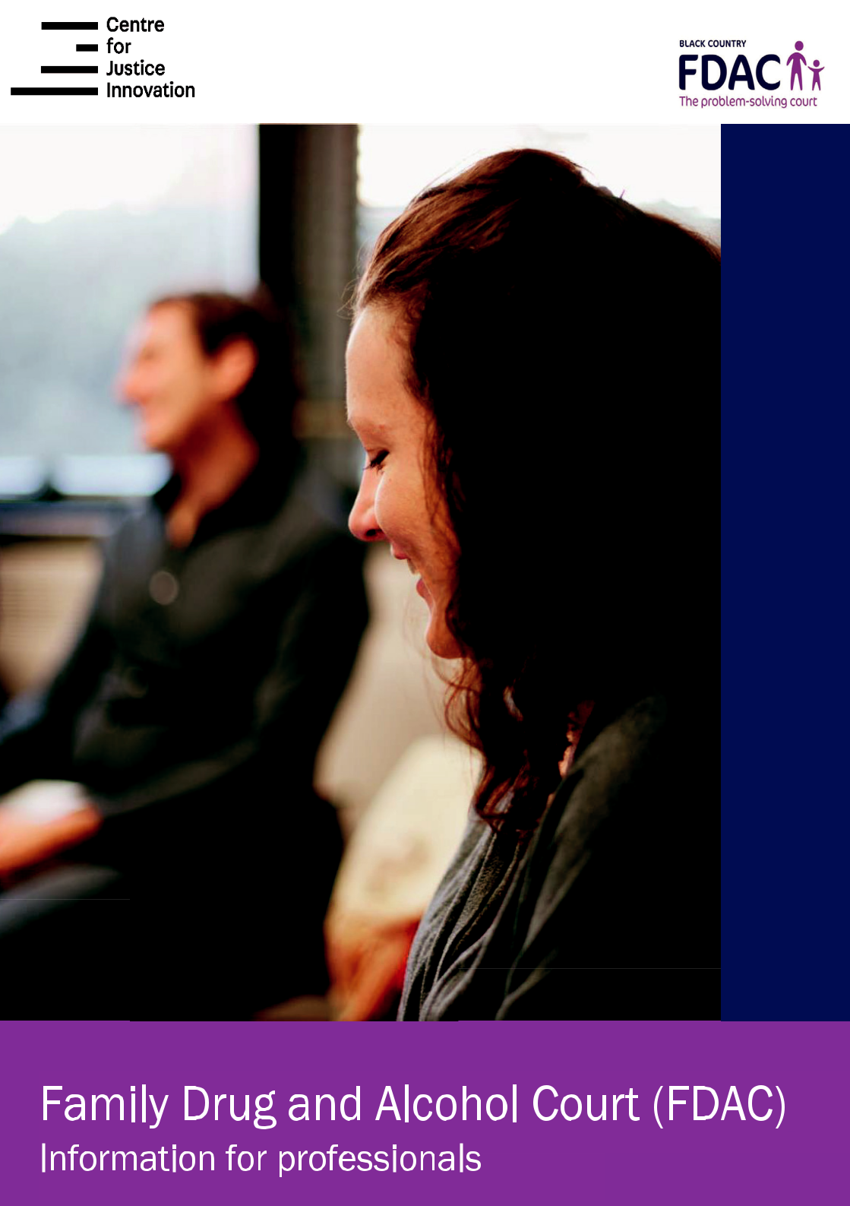
Who is this leaflet for?

This leaflet is for professionals involved in any aspect of the FDAC process, particularly social workers, lawyers, treatment agencies, housing and the like.

Introduction to the Family Drug and Alcohol Court (FDAC)

The Family Drug and Alcohol Court helps families where children are put at risk by parental substance misuse.

FDAC is a problem solving court where the same judge reviews the case every fortnight and is supported by an independent multi-disciplinary Intervention Team. FDAC works with the whole family while keeping the child central. Parents are given ‘a trial for change’ that provides them with the best possible chance to overcome their problems. At the same time FDAC tests whether the family can make enough change in a timescale compatible with the children’s needs.

FDAC achieved significantly better outcomes than normal proceedings in an independent evaluation led by Lancaster University:

- More parents overcame their problems by the end of proceedings

- 40% of FDAC mothers were no longer misusing substances, compared to 25% of the comparison mothers

- 25% of FDAC fathers were no longer misusing substances, compared to 5% of the comparison fathers

- More children remained with or returned to their parents at the end of proceedings. 35% of FDAC mothers stopped misusing and were reunited with their children, compared to 19% of the

comparison mothers

- When families were followed up a year or more after proceedings ended further neglect or abuse of children occurred in 25% of FDAC families compared with 56% of
comparison families

- The researchers said “Parents were overwhelmingly positive about the FDAC team for motivating and engaging them, listening to them and not ‘judging’ them, being honest with them, being both ’strict’ and ‘kind’, providing practical and emotional support, and coordinating their individual plans.”

You can read more about the research if you click on these links:

- Changing Lifestyles, Keeping Children Safe: an evaluation of the first Family Drug and Alcohol Court (FDAC) in care proceedings (May 2014)

- After FDAC: outcomes 5 years later Final Report (December 2016)

In a recent judgement the President of the Family Division of the High Court said of FDAC ‘The FDAC approach is crucially important. The simple reality is that FDAC works … FDAC is, it must be, a vital component in the new Family Court.’ Re S (A Child) [2014] EWCC B44 (Fam), [2014] 2 FLR, at paras [35]-[38]

Selection - the cases that go through the Court

Cases are selected by the Local Authorities. The usual threshold for proceedings applies and if families are not selected for the FDAC they will enter the usual family proceedings court instead. In some places, FDAC works with families pre-proceedings.

There must be a history of parental drug or alcohol misuse that is impacting on, or likely to impact on, the children’s health and development. However, most families have additional problems such as domestic abuse and parental mental health difficulties.

FDAC is most likely to help families who are already demonstrating some willingness to change.

There are only a limited number of places available in FDAC. If a family is selected for the FDAC they will be given written information before the first hearing, and meet the FDAC team at the first hearing. The FDAC is voluntary and if parents do not wish to proceed, their case will be heard in the usual family proceedings court.

Choice for the families

A family may choose to go through the normal care proceedings route. They might do this for any number of reasons, but they should be advised that families with a willingness to change are likely to achieve better outcomes via FDAC.

Like any care proceedings, there is still a potential for the family to lose their children, but the FDAC process has been set up to encourage success and to be as supportive as possible. Whilst they must take the process seriously, as they would do for normal care proceedings, families need not be fearful that the FDAC is there to trap or trick them in any way.

Once a family is chosen they do not have to make a decision immediately. They will be asked at the first hearing (Case Management Hearing CMH) if they want to undertake the initial FDAC assessment; it begins immediately if they
do. The family will be encouraged to talk to their solicitor and the FDAC team if they have any doubts or questions over the process. Between the first and second hearing they will take part in an assessment day and an Intervention Planning Meeting where

the FDAC Intervention Team will help the parties agree a plan which is given the court’s authority at the second Court hearing (Further Case Management Hearing FCMH) usually at the 2nd or 3rd week in proceedings).

After the second hearing, the ‘trial for change’ officially begins and the subsequent fortnightly hearings will be used to provide encouragement, review progress, review the Intervention Plan, problem solve any difficulties that arise and make decisions in order to reach permanency as quickly as possible

Make-up of the FDAC team

The same District Judge, or one of a small team of District Judges, will oversee the whole process and offer support and encouragement.

The family will also receive support from the FDAC Intervention team who will coordinate the Intervention plan. This is a multidisciplinary team, which includes: Child Protection Social

Workers, Psychiatric Nurse, Substance Misuse Specialists and Parent Mentors.
There is also a Child and Adolescent Psychiatrist, an Adult Psychiatrist and
Therapists attached to the team. The London FDAC has a domestic abuse expert. FDAC has named links in the Housing and Domestic Abuse Teams within the Local Authority and elsewhere.

Parent Mentors are volunteers with a history of recovering from addiction and in many cases they have experience of care proceedings. Increasingly Parent Mentors are graduates of FDAC. A Parent Mentor will be present during the Court, assessment and Intervention periods to provide support, encouragement and reassurance.

The court

The court process is slightly different from normal

proceedings. As well as the initial Case Management

Hearing (CMH) there is a Further Case

Management Hearing (FCMH). This allows families the

opportunity to be introduced to the FDAC process at the first

hearing (CMH) and have a full assessment before being

asked to commit themselves at the second hearing (FCMH).

As a part of that commitment the Judge will ask the parents

to sign an undertaking to be open and honest.

The family will work with the same Judge from the FCMH onwards.
If for some reason the family’s Judge is away the family will see a substitute Judge from a small team of back up District Judges.

The parties will be fully represented by their lawyers at the CMH, FCMH and subsequent Issues Resolution Hearing.

However, between the FCMH (normally the 2nd or 3rd week of proceedings) and the IRH (normally the 20th week of proceedings) the family will attend court for a Non-Lawyer Review once a fortnight.

The FDAC Intervention team will brief the Judge about the case prior to the Non-Lawyer Review and produce a short review report, which is shared with all the parties. In court the parents will normally talk directly with the Judge for up to half an hour. A short note of what is said is prepared by the FDAC Intervention Team and distributed to the parties. If the case is proceeding according to plan the next court attendance will normally be another Non-Lawyer review however if there a problem the Judge or any of the parties can ask for the matter to return with lawyers at the next hearing.

The FDAC Judges are specially trained in helping families stay motivated and get better at taking charge of their own lives and solving problems. In practice parents find the Non-Lawyer reviews a little daunting at first, however when things go well they are enormously important to the parents’ sense of self-respect and agency.

Assessments

The FDAC Intervention Team will carry out a series of comprehensive assessments of the family’s strengths and any concerns.

- The initial assessment is completed within the first 2 weeks of proceedings and will identify the timescales for the children, the parents’ goals and
the treatment and support that will be provided in the next 4-8 weeks. This plan will be reviewed in court every 2 weeks and modified and added to a Review Intervention Planning Meetings, which occur every 4-8 weeks.

- Every two weeks FDAC will provide a short review report on what is going well and not going well about the Intervention Plan including attendance for treatment and the results of drug and alcohol testing.

- Sometime in the first 8 weeks of the proceedings the FDAC Child & Adolescent Psychiatrist will chair a Children’s Needs Meeting with the parents, foster carers, teachers, social worker, guardian and potentially others to assess the children’s needs. Where appropriate a full child psychiatric assessment will also be carried out.
- All parents will have a mental health screen at the initial assessment and where appropriate be assessed by the FDAC Adult Psychiatrist, also in the first 8 weeks of the proceedings.

- An assessment of the parents’ relationship with their children and capacity to meet their children’s needs will be undertaken once parents have been abstinent for some months and made some progress with their own problems.

- By the third Intervention Planning Meeting (normally the 18th week in proceedings) the
FDAC Intervention Team will advise whether parents have made enough progress for their child to be permanently placed in their care. The Intervention team will report on this assessment no later than the 19th week of proceedings. The court will then hold an Issues Resolution Hearing (normally the 20th week of proceedings) to decide when to bring the proceedings to an end. This may require a contested hearing some time before the 26th week of proceedings. Alternatively, the decision may be to continue the

proceedings beyond the 26-week mark, for example, to allow time to check on children who have recently been returned home.
- For cases that continue beyond the 26-week mark there will be more hearings and review reports and a final report for the final hearing

Interventions

The FDAC Intervention Team will put in place a range of interventions drawn from the resources in the family’s local authority of residence supplemented by treatments provided by the team. The interventions will be matched to the needs of the individual family but are likely to involve the following:

Abstinence: Parents will be given support and advice on being abstinent

from street drugs and alcohol and abstaining from domestic abuse and criminal activity (for example, community drug and alcohol programmes providing individual and group education and advice on triggers and relapse prevention).

Understanding & repair: Parents will be given support, advice and treatment on understanding the problems underlying any substance misuse, domestic abuse and mental health problems. Nearly all parents need help
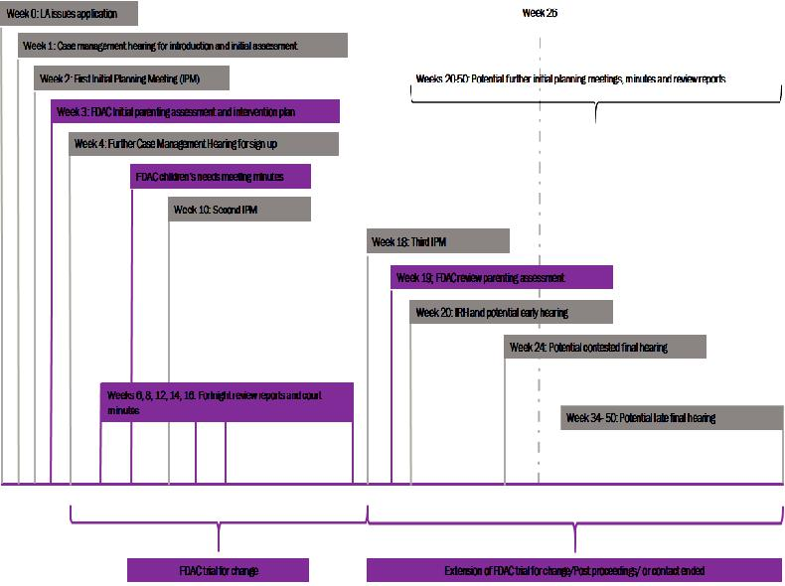

finding safer ways of dealing with the effects of trauma. Many children need help to make sense of the disruptions created by their parent’s difficulties and the intervention of the court. Some parents and children need treatment for

mental health problems including anxiety, depression or post-traumatic stress disorder. (For example parents may be encouraged to attend community based intensive treatment programmes or an anxiety group.)

Strengthening relationships: Parents will be helped to be more sensitive and responsive with their children and strengthen parents’ relationships with each other and the wider family (for example, families will be offered Video Interaction Guidance).

Child centred lifestyle: Families will be helped to develop a lifestyle that prioritises children’s needs, which could include education and training that will allow parents to work

Timetable

The FDAC process is geared to two different timescales: the timescales for the child and the timescales for the court.

Where parents are not meeting their children’s needs the question becomes how long can those children afford to wait for the situation to improve? The answer is that it depends on the children’s age and developmental stage. We call these periods of acceptable delay the ‘children’s timescales’.

For example, with new-born babies we aim to have the child permanently placed by the time they are 12 months old. This is because of the importance of attachment. The sensitive period when children most naturally form an attachment is between 6 and 18 months. Therefore, we want children to have settled with their long term carer inside that sensitive window. This means deciding whether children can return home before they are 9 months old. That leaves a further 3 months to either see how they get on at home or find an alternative permanent placement with extended family or adopters.

With older children timescales are less critical. We are mindful that adoption is less likely to be successful with children beyond the age of 5-6. Similarly, children find it difficult to put down roots in a foster family much beyond the age of 9-10.
The court also has timescales. Just as in normal proceedings the expectation in FDAC is that proceedings will end within 26 weeks when children are not returning home to their parents.

However, the President of the Family Division has cited families making progress in FDAC as one of the reasons the court might allow proceedings to go beyond the 26-week mark. The following table sets out the timetable for the court and how this fits with the assessments and intervention.
Expectations of the families

We believe that no parent wants to cause their child to suffer and that every family in difficulty wants things to get better. However, parents often don’t know how to sort things out and fear that if they ask for help they will be judged and punished. We find things work best when families are able to be open and honest and do their best to work with the trial for change. We hope they will find they are treated with respect and compassion.

Role of the social worker

The Social Worker’s task to protect the child is unchanged. We ask Social Workers to support the family’s trial for change. It is important that the local authority feels satisfied that the expectations on the family are sufficiently demanding to test whether parents have made enough change to be able to meet their children’s need for the foreseeable future. At a more

practical level Social Workers will be expected to attend the lawyer and Non-Lawyer hearings and Intervention Planning Meetings. We would expect the Team Manager to attend Intervention Planning Meetings, Lawyer hearings and they are welcome to attend the Non-Lawyer Reviews.

Role of other professionals

Drug and alcohol workers, domestic abuse and mental health services, housing and others play a vital part in working together to give families the best possible chance to overcome their problems. We will have written permission from the families to be able to communicate with you. The FDAC Intervention Team will want to stay in close contact and gather regular updates for the fortnightly. On occasions they may be invited to attend the Non-Lawyer Reviews.

Role of lawyers in FDAC

The role of the lawyers to advise and represent the parties is unchanged. The more lawyers that understand about the FDAC process the easier that will be. The FDAC team has a rolling programme of seminars to talk about FDAC and gather feedback. Equally we are happy to talk on an individual basis at any time.



68217 03/20

