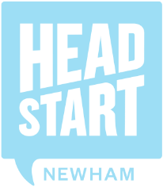
HeadStart is for 10-16 year olds living in Newham who could benefit from additional support to help them build their resilience and improve their wellbeing. If you are working with a young person in this target group, please recommend them to us using this form. We will ensure that the HeadStart service or its commissioned partners contacts the young person to encourage them to take part. If the young person is seeing a mental health professional such as a CAMHS doctor or a psychologist, then HeadStart is probably not right for them at the moment. However, in the future, it might be and you can always come back to us to recommend them.
HeadStart offers the following targeted resilience building activities:
Professionals Recommendation Form
For young people attending any Newham school
A range of age appropriate creative and sports activities in the community for young people (Aged 10-16)
Case Worker details
Name |  | Job title
Organisation/  school |  | Email
Contact number |  | Date

Young Person’s details
First name |  |  | Surname
Address
Mobile number
Postcode |  | Gender
Date of birth |  | Form / Year group
School name

Why are you recommending this young person?

HeadStart works with young people who could benefit from additional support in the following areas. Please mark which areas the young person is having difficulty. If the young person is currently being seen by CAMHS or on the waiting list to be seen, they are not eligible to take part in HeadStart. Please refer to HeadStart Target Population Criteria Guidance on page X for more information.
*NB. If interested in becoming a mentor, these criteria can be ticked for historical difficulties
Mild emotional difficulties | ☐
Mild behavioural difficulties | ☐
Mild difficulties getting on with other people | ☐
Mild concentration difficulties | ☐
I can confirm that this young person is not currently being seen or  waiting to be seen by a specialist mental health service (CAMHS) | ☐
RISK ASSESSMENT
AREA
HEALTH/MEDICAL NEEDS
SAFETY & WELLBEING
ANY RESTRICTIONS
LEARNING STYLES/SEND | ☒
LEVELS OF RISK
(please circle) LOW MEDIUM HIGH
COMMENTS
(group readiness, engagement &
compliance issues)

I am happy for the information on this form to be shared with HeadStart partners ☐ YES

Please return form directly to the HeadStart team at: newhamheadstart@cgl.org.uk
IMPORTANT: use password protected email if non LBN service or school
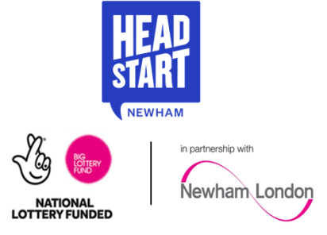
We will ensure that we make contact with the young person you have recommended within the next month. Together, with the young person, we make a joint decision if they fit the criteria for HeadStart and whether they would like to take part in a HeadStart activity.

