Organisation:
Date:
Forename:  Surname: |  | Date of Birth:
School:
Young Person Telephone No: |  | Address:  Postcode:
Parent/ Emergency contact Name: |  | Parent/ Emergency Contact Telephone No:
Additional Educational or Medical Needs:
Name and email address of trusted adult in school/other professional:
What made you come today?
Is there something specific you are looking to work on by taking part in this activity?
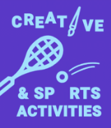
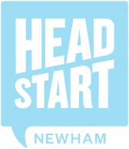
Creative Arts & Sports Activities Registration

Young Person’s Details

PROFESSIONAL TO COMPLETE
Date of first Session: |  | Name of session:
Date of final session: |  | Total no. of sessions attended:
Date of pre survey: |  | Date of post Survey:
Notes:
Include dates of 1:1’s

FOR OFFICE USE ONLY
Entered on ChildView | Yes / No | Young Person/Parent called and/ or emailed | Yes / No  Date:
Date and Follow up agreed | Yes / No  Follow up date: | Outcome recorded on ChildView | Yes / No  Date:
Target Population completed: | Yes/No

How does the young person meet the target population criteria?
To be completed at first 1:1 in conversation with the young person
these criteria can be ticked for historical difficulties
No difficulties | ☐
Mild difficulties with emotions | ☐
Mild difficulties with behaviour | ☐
Mild difficulties with relationships/getting on with others | ☐
Mild difficulties with concentration | ☐
Currently under CAMHS | ☐ Yes ☐ No

